Progress Test Unit 3
1. Translate the words. 14 points.

- To enter
- Делать успех
- To distract from
- Завалить
- Night school
- Режим дня
- Studies
- Почасовая работа
- Optional subjects
- Большинство
- Secondary education
- Основные предметы
- Primary school
- Общеобразовательная школа

2. Fill in the gaps using Conditional 3. 15 points.
- I … (visit) Sarah yesterday if I … (know) that she was ill. (Я бы навестил Сару вчера, если бы знал, что она больна.)
- If you … (go) with me to Paris last month, you … (see) the Eifel Tower too. (Если бы ты поехал со мной в Париж в прошлом месяце, ты бы тоже увидел Эйфелеву башню.)
- We … (not get wet) if you … (take) an umbrella. (Мы бы не промокли, если бы ты взяла зонт.)
- If Mum … (not open) the windows, our room … (not be) full of mosquitoes. (Если бы мама не открыла окна, наша комната не была бы полна комаров.)
- Nick … (not be) so tired this morning if he … (go to bed) early last night. (Ник не был бы таким уставшим этим утром, если бы рано лег спать прошлой ночью.)
3. Match the sentences and write down the translation. 12 points.
1) We would have made a cake a) if he hadn’t shouted at them.
2) If it rains much b) if she loses weight.
3) If I knew English well c) if we had bought some eggs yesterday.
4) My kids wouldn’t have cried d) if I were you.
5) I would call him e) I would be an interpreter.
6) She will put this dress on f) the flowers will grow very fast.
4. Complete these short conversations using MUST+HAVE+V3 and CAN’T+HAVE+V3. 10 points.
- – Is it true that Jack failed his exams? – He … (fail) the exams. He studied hard during the year.
- – I’ve heard that Mary and Ann have quarrelled badly. – They … (quarrel). I’ve just seen them talking.
- – I thought Jack and Fred were friends! Now look at them fighting! – They … (quarrel). Sometimes they just can’t agree.
- – I’ve heard Tim has finished school. Do you know where he is now? – He … (enter) university. He was the top student in our school.
- – Jack has dropped out of school, hasn’t he? – He … (drop) out of school. He’s got many friends in this school and he’s quite a good student.
5. Fill in the gaps using the words from the box. 20 points.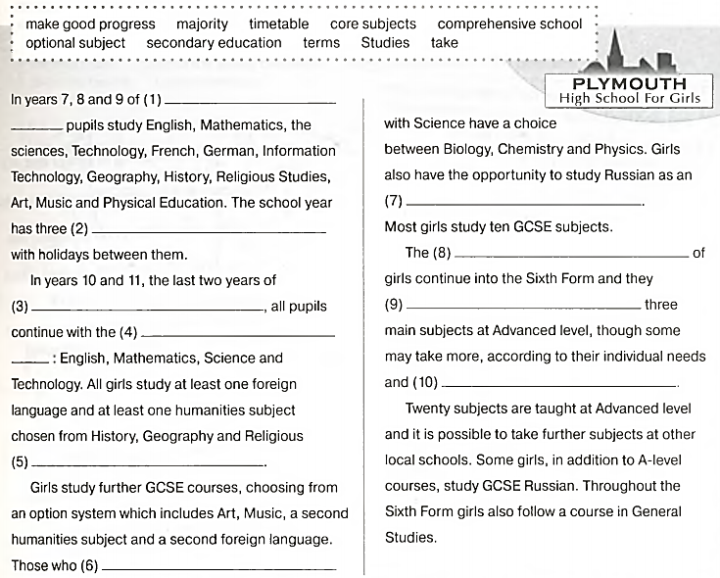
6. Read the text and write whether the following statements are true (T) or false (F). 7 points.
1. Cleo thinks that special lessons helped her more than individual work. |  | 5. In revision lessons students had a chance to learn important new material.
2. She produced special materials that helped her learn. |  | 6. In revision lessons the teacher gave the students tasks similar to exam activities and they had to do them at home.
3. Cleo tried to deal with easier subjects before dealing with more difficult ones. |  | 7. Cleo passed her exams successfully.
4. Clleo enjoyed preparing for exams with her fellow students.
